

**CUSTOMER FEEDBACK FORM**

Date: ________________ Time In: _____________

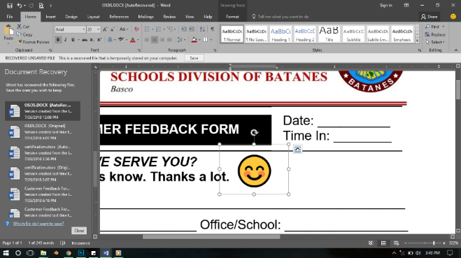

***HOW DID WE SERVE YOU?***

**Please let us know. Thanks a lot.**

NAME: __________________________________________________________

Position: ________________________ Office/School: _________________

Address: ________________________ CP #: __________________________

1. **PURPOSE OF VISIT: (Please check (✓) all applicable)**

**( ) INQUIRY/CONFERENCE ( ) SUBMISSION/ PROCESSING**

**( ) REQUEST ( ) OTHERS ________________**

|  |  |
| --- | --- |
| **OFFICE OF THE SCHOOLS DIVISION SUPERINTENDENT** | |
| ( ) MOOE/other funds  ( ) Record/Certification  ( ) Leave/ Travel  ( ) Legal/ICT | ( ) Loan/s  ( ) Assessment/ Appointment  ( ) Supply/ Property  ( ) Others: _______________ |

|  |  |
| --- | --- |
| **CURRICULUM IMPLEMENTATIONS DIVISION** | |
| ( ) LR/ IMs  ( ) Curricular PPAs: _______  ( ) TA  ( ) Curriculum Delivery (Inclusive K to 12/ ALS) | ( ) Instructional Supervision  ( ) Assessment of Learning/ Testing  ( ) Others: _______________ |

**II. HOW WOULD YOU RATE OUR SERVICE? (Please put a check (✓) mark)**

|  |  |
| --- | --- |
| **SCHOOL GOVERNANCE AND OPERATIONS DIVISION** | |
| ( ) ME/ TA  ( ) L&D/ HRD Matters  ( ) School Governance/SBM  ( ) Physical Facilities  ( ) Research & Innovation | ( ) Data Management (LIS/BEIS)  ( ) Partnership & Networking  ( ) Health & Nutrition  ( ) Others: _______________ |

**4** – Outstanding **2** – Satisfactory

**3** – Very Satisfactory **1** - Unsatisfactory

|  |  |  |  |  |
| --- | --- | --- | --- | --- |
| ***How satisfied were you in terms of the service provided****:* | **4** | **3** | **2** | **1** |
| 1.response time to your transaction given by the Office? |  |  |  |  |
| 2.outcome of the service provided? |  |  |  |  |
| 3.extensive info on / understanding of the service provided and/or competence/skill in delivering the service? |  |  |  |  |
| 4.friendliness, courteousness, fair treatment and willingness? |  |  |  |  |
| 5. OVERALL satisfaction with regard to quality of service delivery? |  |  |  |  |

**III. COMMENDATION(S)/ RECOMMENDATION(S)/ COMPLAINT/ SUGGESTION(S)/ DESIRED ACTION FROM OUR OFFICE?**

____________________________________________________

____________________________________________________

____________________________________________________

**PROCESSING TIME**

TIME START: _______________ TIME OUT: ________________

|  |  |
| --- | --- |
| Personnel who attended you |  |
|  |

FM-SDS-005 Rev. 00 As of: Jul 2, 2019